- SonarQube Analysis Report
SonarQube was integrated into the CI/CD pipeline to perform static code analysis on the developed applications. It evaluates important code quality metrics such as bugs, vulnerabilities, code smells, duplication, and test coverage. This helps in identifying issues early and improving the overall quality and maintainability of the code.
- Analysis Summary
The SonarQube dashboard shows that both projects (appv2 and gym-app) have successfully passed the Quality Gate.
- Bugs: 0 (No reliability issues detected)
- Vulnerabilities: 0 (No security issues found)
- Code Smells: Minor issues detected (related to code duplication and maintainability)
- Coverage: ~12–17% (indicates limited test coverage using Pytest)
- Duplications: ~59–68% (high duplication observed in code)

- Issues Identified
From the issues tab, the main problem identified is:
Repeated use of the same string literal ("Client not found") across multiple files
SonarQube recommends defining it as a constant instead of duplicating it
This improves:
Code maintainability
Readability
Reusability
- Conclusion
The project meets basic quality standards as it passes the Quality Gate with no critical bugs or vulnerabilities. However, improvements can be made by reducing code duplication and increasing test coverage to enhance overall code quality.

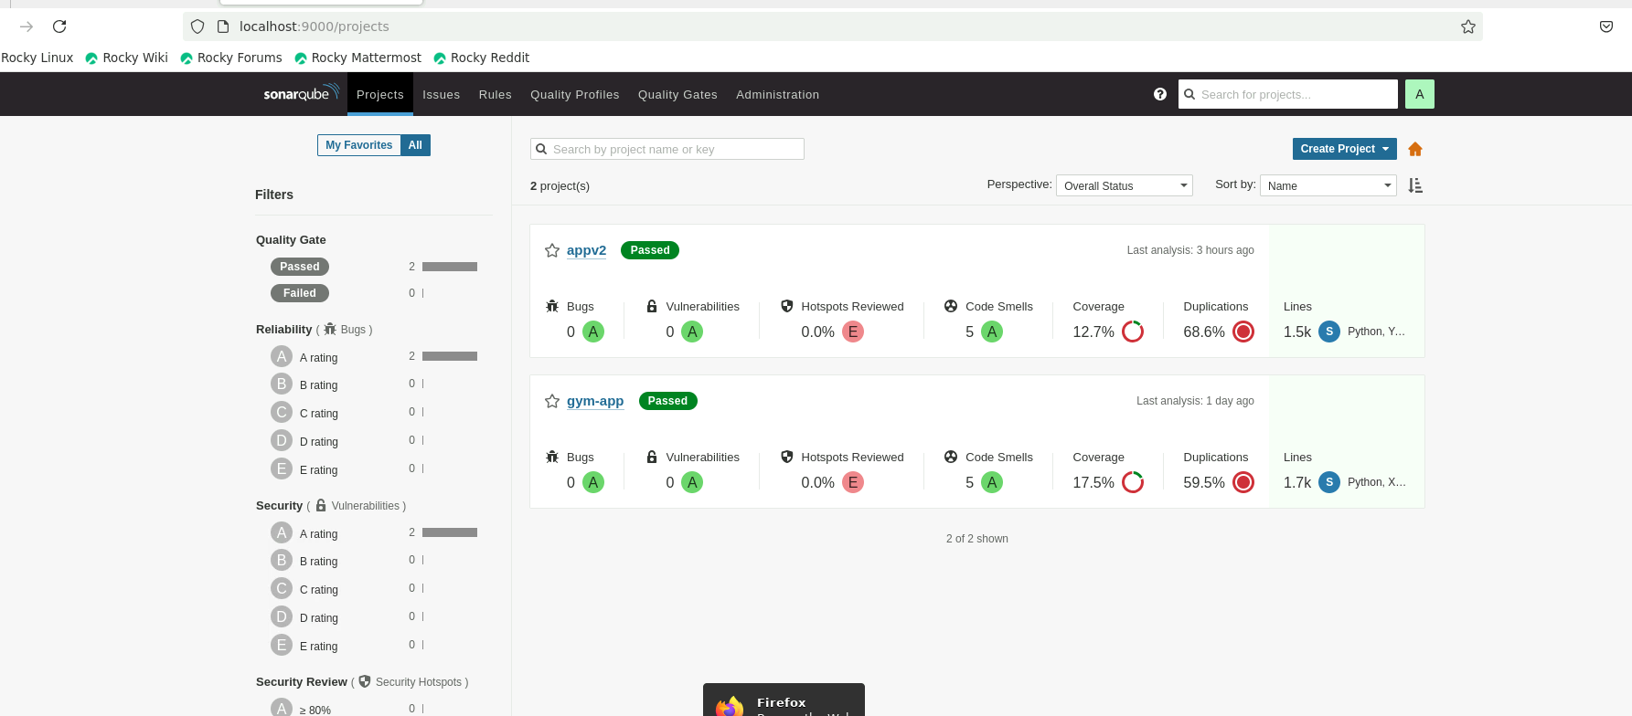
Fig 1: SonarQube Project Dashboard
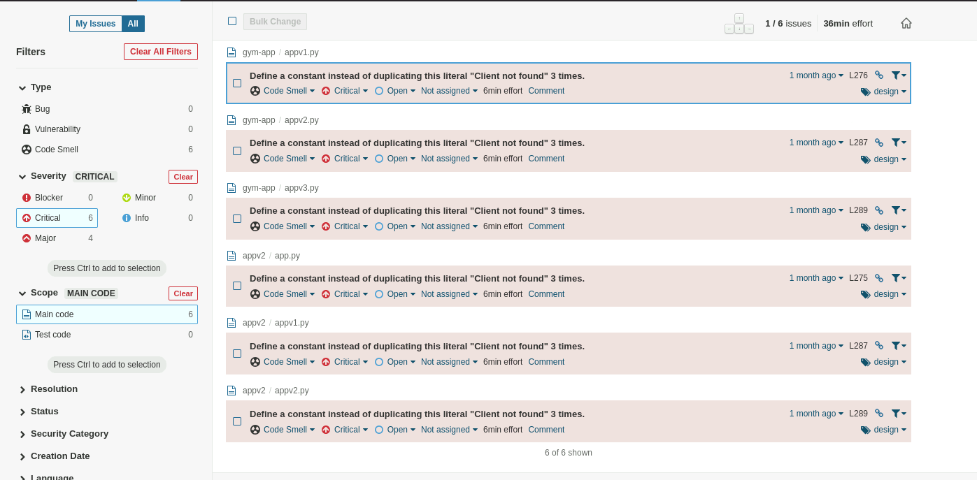

Fig 2: SonarQube Issues View

